Project Report
Auto Ticket Classification Using ServiceNow Flow Designer
Team: Sangavi P (Team Lead), Kanchana J, Haritha S, Sri Poornima S
1. INTRODUCTION
1.1 Project Overview
The school IT helpdesk receives multiple incidents every day from students and teachers, such as Wi-Fi connectivity issues, projector failures, password-related problems and slow computers. This project uses ServiceNow Flow Designer to classify these incidents automatically. When an incident is created, the flow checks the Short Description for keywords and updates the Category and Subcategory.
1.2 Purpose
The purpose is to remove the manual step of categorising each incident, to make classification consistent and to let IT staff start resolution sooner.
2. IDEATION PHASE
2.1 Problem Statement
IT staff manually review each incident and assign a category. This is time-consuming and different staff members may choose different categories for the same kind of problem (PS-1 to PS-3).
2.2 Empathy Map Canvas
Callers say they need quick help, think that they cannot judge the right category, do nothing more than describe the issue and feel frustrated by delays. Staff feel overloaded by sorting work.
2.3 Brainstorming
Ideas such as a Flow Designer flow, dependent choice fields, a Category is Empty trigger condition, email notification and machine learning were compared on effort and impact. The Flow Designer flow with keyword conditions was selected; email notification and machine learning were deferred.
3. REQUIREMENT ANALYSIS
3.1 Customer Journey Map
The journey covers awareness of the problem, incident creation, automated classification, review by staff and closure. The automation acts between creation and review.
3.2 Solution Requirement
Functional requirements FR-1 to FR-6 cover incident creation, automatic trigger, keyword evaluation, category assignment, dependent choices and review. Non-functional requirements NFR-1 to NFR-6 cover usability, security, reliability, performance, availability and scalability.
3.3 Data Flow Diagram
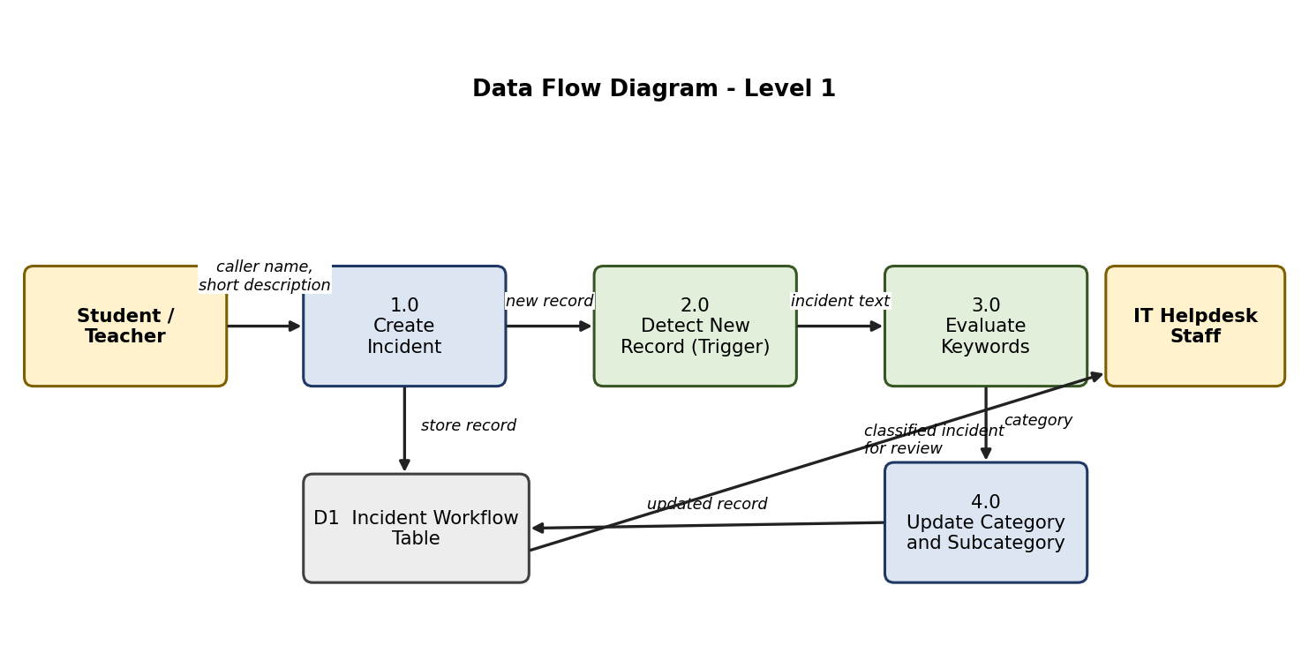
3.4 Technology Stack
ServiceNow platform UI, Flow Designer (trigger, Flow Logic, Update Record), a custom table in the ServiceNow database and an update set exported as XML. No external APIs and no machine learning are used.
4. PROJECT DESIGN
4.1 Problem Solution Fit
The solution fits the problem because callers keep entering a name and short description as before, and the classification step that caused delay is done by the flow.
4.2 Proposed Solution
A flow named Auto Classify School IT Tickets runs on Record Created when Category is Empty. If / Else If conditions on the Short Description assign the categories listed below.
Keyword in Short Description | Category | Subcategory
Wi-Fi / Network | Network | WiFi
Projector | Hardware | Projector
Password / Login | Access | Forgot Password
Slow / Hanging | Performance | Slow Computer

4.3 Solution Architecture
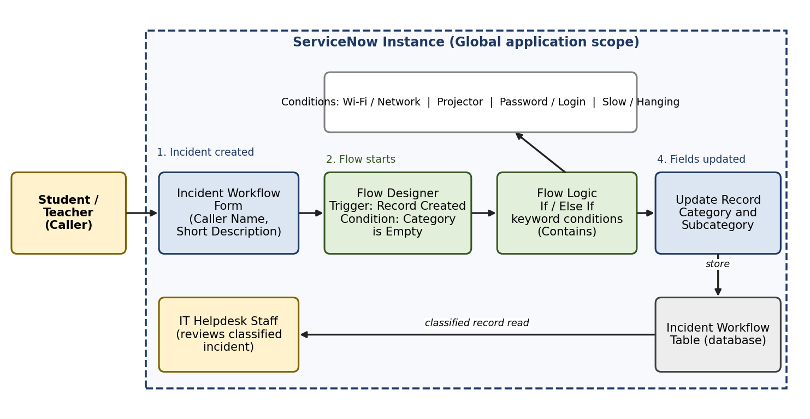
5. PROJECT PLANNING & SCHEDULING
5.1 Project Planning
Work was divided into 10 user stories (25 story points) over two sprints: Sprint-1 = 16 story points and Sprint-2 = 9 story points. The average velocity is 12.5 story points per sprint. The five SkillWallet milestones are: Requirement Analysis & Planning; Backend Development & Configuration; Automation using Flow Designer; Testing, Validation & Security; Deployment & Conclusion.
6. FUNCTIONAL AND PERFORMANCE TESTING
6.1 Performance Testing
Eleven functional tests (FT-01 to FT-11) and two performance tests (PT-01, PT-02) were executed. All keyword rules produced the expected Category and Subcategory, an incident with no keyword stayed unclassified without error, and an incident with a Category already set was not changed. UAT: 10 of 10 test cases passed; one low-severity observation (BG-001) was closed as by design.
Test Case | Input (Short Description) | Expected Result | Actual Result
TC-001 | Wi-Fi is not connecting | Network / WiFi | Network / WiFi
TC-003 | Projector is not displaying | Hardware / Projector | Hardware / Projector
TC-004 | Forgot my password | Access / Forgot Password | Access / Forgot Password
TC-006 | Computer is running very slowly | Performance / Slow Computer | Performance / Slow Computer
TC-008 | Request for a new chair | Category empty | Category empty

7. RESULTS
7.1 Output Screenshots
[INSERT SERVICENOW INCIDENT SCREENSHOT HERE]
[INSERT FLOW DESIGNER SCREENSHOT HERE]
8. ADVANTAGES & DISADVANTAGES
Advantages: reduced manual effort; consistent classification; faster start of resolution; no-code and easy to maintain; new keywords can be added as conditions.
Disadvantages: only configured keywords are recognised; spelling variants need extra conditions; unmatched incidents still need manual classification.
9. CONCLUSION
The project automated the classification of school IT helpdesk incidents with ServiceNow Flow Designer. Incidents containing Wi-Fi / Network, Projector, Password / Login or Slow / Hanging keywords receive the correct Category and Subcategory when they are created, which reduces manual effort and improves consistency.
10. FUTURE SCOPE
Possible enhancements: email notification to the caller on ticket creation; rules for software and printer incidents; evaluation of the Description field with more keywords; assignment of incidents to support groups.
11. APPENDIX
Source Code (if any): No custom code; the solution is a no-code Flow Designer flow captured in the Project Update Set (XML export).
Dataset Link: Not applicable.
GitHub & Project Demo Link: [INSERT GITHUB / DEMO LINK HERE]

